A REPORT OF CAPACITY BUILDING WORKSHOP IN NEPAL

BACKGROUND

National Society for Earthquake Technology-Nepal (NSET) was established in 1993 by a group of scientists and engineers in order “to foster the advancement of science and practice of earthquake engineering and technology for mitigating the earthquake risk and increasing the seismic safety, to enhance professionalism, professional engineering and scientific ethics and to further the objectives of the International Association for Earthquake Engineering as applicable to Nepal”.

Facing the growing challenge of disaster risk, particularly after the earthquake in 2015 with 9,000 people killed and 22,000 injured, NSET feels the necessity to further build the organizational capacity to fill the gap of their current operation and the needs in the society.

In taking their first step, NSET invited ADRRN Tokyo Innovation Hub (ATIH) to convene an innovation workshop in March 2017.

OBJECTIVE

The objectives of this workshop are:

To develop understanding of innovation by doing exercise using Human-Centered Design Methods
To develop new ideas through the group work with members from different division

PARTICIPANT

23 participants, mostly Managers attended the workshop. Each of them was asked in prior to the workshop to bring 3 issues that the person thinks the most significant to NSET and needs to be discussed. Mr. Amod, the Executive Director, was also present to make sure the generated ideas were in line with the organizational strategy.

PROGRAM

The workshop was 1 day session, and the participants worked in 3 randomly selected groups to diversify team members. In the morning, the concept of innovation was introduced by ATIH, followed by the group work using the Human-Centered Design Methods tool developed by LUMA Institute. Each group was first asked to select the issues the participants brought in using ‘Importance/Difficulty Matrix’ to evaluate and identify the major issues at the organizational level. Next, the group discussed causes and effects of the issues to understand the surrounding elements and see the issue with the holistic view by adding perspectives of the team members from different divisions. In the afternoon, the members tried to come up with unconventional ideas by freeing their mind. A tool called ‘Round Robin’ was used to identify both challenges and solution, and repeat the process in the limited time until the idea takes some shape. Finally, each group produced a ‘Concept Poster to present their project concept.
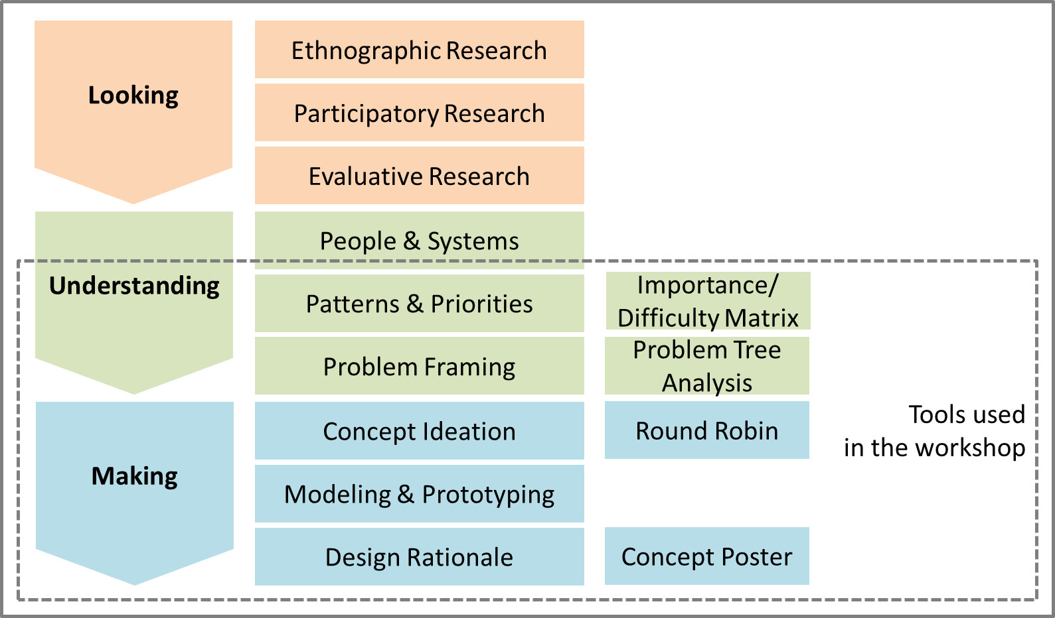

OUTCOME

As an output of the workshop, 4 unconventional ideas were generated, and discussed among all participants as to how NSET can improve the ideas and implement them. 4 ideas included Improving culture of safe construction practices using tax incentive, Establishing Gender Equality and Social Inclusion (GESI) data hub for better coordination, Disaster education adaptive to local geo-climatic condition, and Remote aseismic inspection.

One of the ideas aims at solving one of the key recovery bottlenecks; insufficient number of engineers who can perform on-site seismic assessment of buildings. After the earthquake in April 2015, the reconstruction of buildings in Nepal would require seismic assessment and periodic checks by the engineers in order to progress, but as many engineers in Nepal choose to work abroad, there is shortage of engineers who can perform this critical service. The team asked, ‘will the engineers need to be on-site for seismic assessment?’ And if the answer is ‘no’, then how can the seismic assessment be done even if the engineers are not present on-site? The question prompted ATIH to bring up a technology that Japan Conservation Engineers, Co. Ltd (JCE) is developing. The idea is to use photographs with Photoscan software, which can be converted into 3-D model, then to CAD system for engineer groups to assess the structural strengths of the building.

The project is still at initial inception phase, but is progressing as potential multi-sectoral technological approach to solve the unsolved.

Evaluation session conducted after the workshop revealed that many participants appreciated the opportunity for this innovation workshop, some of their comment included ‘great opportunity to intensively discuss the issues with members from different division,’ ‘the workshop is needed to give new perspective to existent issues.’

FORWARD
The ideas generated in the workshop will be further discussed within NSET members, supported by ATIH in reaching partners and other innovation resource, and promising ideas are to be tested as a pilot and proposed to HIF seed fund.

RESOURCE

LUMA Institute
https://www.luma-institute.com/

